UNIT 1 WATER PART - A
1. Explain hardness of water and mention units to express hardness. (May 12)
Hardness of water
Water which does not produce lather readily with soap solution, but forms white precipitate is called hardness of water. It is due to presence of bicarbonates, sulphates and chlorides of calcium and magnesium,
Units to express hardness of water
- parts per million (ppm) (ii) milligrams per litre (mg/L)
(iii) Clarke’s degree (°Cl) (iv) Degree French (°Fr)
2. List the difference between temporary and permanent hardness. (May 11, May 19)
Temporary or carbonate hardness | Permanent or non-carbonate hardness
(i) Due to carbonates and bicarbonates of calcium and magnesium  (ii) It can be removed by boiling. | Due to chloride and sulphates of calcium, magnesium  Process like Lime-Soda, Zeolite and Ion exchange process are used to remove hardness.

3. How to calculate hardness and why it is expressed in CaCO₃ equivalent? (Jan 11, Jan 14, May 15)
Expression to calculate Hardness of water
Hardness in terms of equivalent of CaCO₃ = (Weight of hardness producing substance x Chemical equivalent of CaCO₃) / Chemical equivalent of hardness producing substance

Reason to express hardness on CaCO₃ equivalent

CaCO₃ is most insoluble salt that can be precipitated in water treatment.

Its molecular weight is 100 and equivalent weight is 50.
4. Explain boiler feed water and what are disadvantages of using hard water in boilers?
Boiler feed water
Water free from hardness substances suitable for generating steam in boiler is called boiler feed water. It should have less than 2 ppm hardness.
Disadvantages of using hard water in boilers
(i) Sludge and Scale formation (ii) Caustic embrittlement
(iii) Boiler Corrosion (iv) Priming and Foaming.
5. Differentiate sludge and scale. (May 13, Jan 14)
Sludge | Scale
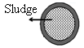  (i) Sludge is loose and non-adherent precipitate.  (ii) Caused by MgCl₂, MgCO₃ & MgSO₄.  (iii) They are poor conductors of heat and decreases efficiency of boiler.  (iv) Prevented by using softened water and blow down operation. | 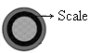  Scale is hard adherent coating.  Caused by Ca(HCO₃)₂ and CaSO₄.  They decrease efficiency of boiler and may lead to explosion.  - Prevented by thermal shocks and dissolving by HCl and EDTA.

6. What are the internal treatment processes to prevent scale formation?

Internal treatment processes to prevent scale formation

(i) Carbonate conditioning (ii) Colloidal conditioning (iii) Phosphate conditioning

(iv) Calgon conditioning (v) Electrical conditioning (vi) Radioactive conditioning

7. Explain Caustic embrittlement and how it can be avoided? (Nov 11, Jan 13, May 14)

Caustic embrittlement

Caustic embrittlement caused when Na₂CO₃ decomposes to give sodium hydroxide. This flows into minute hair-cracks were water evaporates and concentration increases. This caustic soda attacks surrounding area, thereby dissolving iron of boiler as sodium ferroate.

Prevention of Caustic embrittlement
(i) By using sodium phosphate or sodium sulphate instead of sodium carbonate.
(ii) By adding tannin to boiler water which blocks hair cracks.
8. Define boiler corrosion and its causes. (May 11, May 15)
Boiler corrosion
Boiler corrosion is decay of boiler material by chemical or electrochemical attack of its environment. Reasons for boiler corrosion

Dissolved oxygen, CO₂ and acids from dissolved salts
9. Write the difference between Priming and Foaming. (May 11)
Priming | Foaming
(i) Priming is the steam contains droplets of water  - Caused by dissolved solids, sudden boiling  and steam production  (iii) Avoided by fitting purifiers, rapid change in steaming rate and maintaining low water level. | Foaming is production of persistent foam or bubbles, which do not break easily  It is due to presence of oils in boiler water  Avoided by anti-foaming castor oil and removing oil by adding sodium aluminates.

10. What is EDTA and why buffer is added in the estimation of hardness of water? (May 15)
EDTA
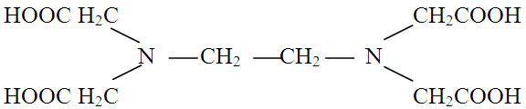
EDTA is Ethylene Diamine Tetra Acetic Acid, forms stable complex with metal ions which is used to estimate hardness of water.

Addition of Buffer

Hardness of water is estimated by using EDTA and Eriochrome black-T indicator and buffer is added with water sample to maintain the pH around 10.
11. What are Zeolites? How is exhausted zeolite softener bed regenerated? (May 14)
Zeolites
Zeolites are hydrated sodium alumino silicates, capable of exchanging its sodium ions for hardness producing ions in water. It may be represented as, Na₂O. Al₂O₃. x SiO₂. y H₂O.
Regeneration of Zeolite
Treating with concentrated (10%) brine (NaCl) solution.
12. Differentiate various softening process.
Lime – Soda process | Zeolite or Permutit process | Ion-exchange or Demineralization process
(i) Precipitation process  (ii) Hardness is 15-50 ppm  (iii) Contains less sodium salts  (iv) Plant occupies more space and capital cost is lower. | Exchanges only cations  Hardness is 10–15 ppm  Contains larger sodium salts Occupies less space and material cost is high. | Exchanges cations and anions  Hardness is 0-2 ppm  Does not contain any ions Equipment is costly and expensive chemicals are needed.
13. What are ion exchange resins? Mention chemicals used to regenerate exhausted resin? (Nov 10)
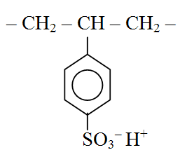
Cation exchange resins
Cation exchange resins are high molecular weight, cross linked polymer containing sulphonic, carboxylic groups are capable of exchanging their H⁺ ions with other cations.
E.g. Sulphonated Styrene divinyl benzene copolymers.
Anion exchange resins
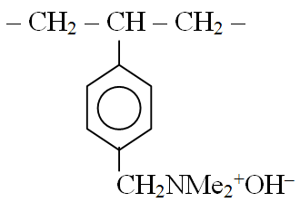
Anion exchange resin is a polymer containing amine or quarternary ammonium group are capable of exchanging their anions with other anions.
E.g. Styrene divinyl benzene copolymers containing quaternary ammonium groups.
Regeneration of ion exchange resins
Cation exchange column is regenerated by dilute HCl.
Anion exchange column is regenerated by dilute NaOH.
14. What are the functions of lime and soda and their requirement in Lime–Soda process?
Function of Lime
Soluble calcium and magnesium salts in hard water are converted into insoluble compounds by lime.
Function of Soda
Soda reacts with calcium present originally and permanent calcium introduced during reactions of lime with acids, etc.
Lime requirement
Lime required = 74 / 100 [temp Ca²⁺ + 2 temp Mg²⁺ + perm Mg²⁺] mg/L in CaCO₃ equivalent.
Soda requirement
Soda required = 106 / 100 [perm Ca²⁺ + perm Mg²⁺ ] mg/L in CaCO₃ equivalent.
15. What is Desalination? Explain two methods. (May 14, Jan 15)
Desalination
Process of removing common salt and other minerals from saline water is known as Desalination which is used for human consumption or irrigation.
(i) Reverse Osmosis
In Reverse Osmosis (RO) process, water solvent is forced to move from brine solution by applying excess of osmotic pressure which is separated by a semi-permeable membrane.
(ii) Electro dialysis
Electrodialysis (ED) is used to transport salt ions from one solution to another through ion-exchange membranes under the influence of applied electric potential difference.
PART – B

1. Explain determination of hardness of water by EDTA method. (May 12, 13, 14, Jan 13, 15)
EDTA method - Determination of hardness of water
Hardness of water
Hardness of water is due to dissolved bicarbonates, carbonates (Temporary) and chlorides, sulphates of calcium and magnesium (Permanent).
Principle
Ethylene Diamine Tetra Acetic acid (EDTA) is a tetra carboxylic acid which forms stable complexes with di and polyvalent metals.


Indicator used is Eriochrome Black–T (EBT) which is a tribasic acid dye having blue colour. Ammonia buffer is used to maintain pH about 10 for the reactions.
When a drop of indicator is added to hard water at pH 10, Ca and Mg – indicator complex will be formed producing red colour.
When EDTA solution is gradually added, it will form more stable complex with Ca and Mg ions leaving indicator ion free, which is blue in colour indicates the end point.
Reactions
Metal ions + EBT Metal ions – EBT
(Ca²⁺ / Mg²⁺) (indicator) (weak complex, wine red colour)
Metal ions – EBT + EDTA Metal ions – EDTA + EBT
(unstable, wine red colour) stable complex blue colour
Titration
Standardization of EDTA solution: 50 mL of standard hard water is taken in a conical flask and 10 mL of buffer solution and 3 drops Eriochrome Black-T indicator are added. It is titrated with EDTA solution taken in burette till wine red color changes to blue. Let the volume used be V₁ mL.
Titration of temporary hard water: 50 mL of water sample is titrated with EDTA. Let volume be V₂ mL.
Titration of Permanent hardness: 250 mL of water sample is boiled till volume reduced to about 50 mL in a beaker. It is filtered and washed with distill water and made up to 250 mL. Then 50 mL of boiled water sample is titrated with EDTA. Let volume be V₃ mL.
Calculations
Total hardness of water = 1000 V₂ / V₁ mg/L or ppm
Permanent hardness = 1000 V₃ / V₁ ppm
Temporary hardness = 1000 (V₂ – V₃) / V1 ppm

2. Write note on Scale and Sludge formation in boilers. (Nov 11, 12, May 11, 14, 16)

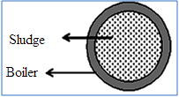
Sludge

Sludge is a soft, loose and slimy precipitate formed in boiler which can be scrapped off with a wire brush.

It is formed at colder portions of boiler and collects, where the flow rate is slow or at bends.

Sludge is formed by substances which have greater solubility in hot water than in cold water.

Substances causing Sludge: MgCO₃, MgCl₂, CaCl₂ and MgSO₄.

Disadvantages of sludge formation
- Sludges are poor conductor of heat, tend to waste a portion of heat generated.
- If sludges are formed along with scales, then it gets entrapped in scale.
- Excessive sludge formation disturbs working of boiler.

Prevention of sludge formation
- By using well softened water.
- By frequent blow down operation, i.e., drawing off portion of concentrated water.

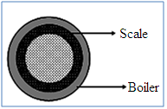
Scales
Scales are hard deposits, stick very firmly to inner surfaces of boiler. Scales are difficult to remove, even with hammer and chisel.
Scales are the main sources of boiler troubles.

Formation of scales

(i) Decomposition of calcium bicarbonate

(ii) Deposition of calcium sulphate

(iii) Hydrolysis of magnesium salts and presence of silica

Disadvantages of scale formation
(i) Wastage of fuel
(ii) Lowering efficiency and boiler safety
(iii) Danger of explosion

Removal of Scales
- With help of scraper or piece of wood or wire brush, if they are loosely adhering.
- By giving thermal shocks, i.e., heating boiler and then suddenly cooling with cold water.
- Dissolving them by adding chemicals such as HCl and EDTA.
- By frequent blow-down operation, if scales are loosely adhering.

3. Explain internal treatment processes to prevent scale formation. (Jan 11, May 11, 12, 15)
Internal treatment processes
An internal treatment is accomplished by adding a proper chemical to boiler water itself. This is either to precipitate scale forming impurities in form of sludges or to convert them into compounds and thus do not cause any harm. This precipitate is removed by blow-down operation
(i) Colloidal conditioning
In low pressure boilers, scale avoided by adding organic substances (kerosene and tannin). This get coated over scale forming precipitates, yielding non sticky and loose deposits.
(ii) Phosphate conditioning
In high pressure boilers, scale avoided by adding sodium phosphates. This reacts with hardness of water forming soft sludge,.
CaCl₂ + Na₃PO₄ Ca₃(PO₄)₂ + NaCl
(iii) Carbonate conditioning
In low pressure boilers, scale avoided by Na₂CO₃. The CaSO₄ is converted as loose sludge of CaCO₃.
CaSO₄ + Na₂CO₃ CaCO₃ + Na₂SO₄
(iv) Calgon conditioning
It involves in adding calgon [sodium hexa meta phosphate, (NaPO₃)₆] to boiler water. It prevents scale and sludge formation by forming soluble complex compound with CaSO₄.
CaSO₄ + [NaPO₃)₆] [Ca₂P₆O₁₈]²⁻ + Na₂SO₄

(v) With sodium aluminate
Sodium aluminate gets hydrolysed yielding NaOH and aluminium hydroxide which precipitates magnesium as Mg(OH)₂. MgCl₂
NaAlO₂ + H₂O NaOH + Al(OH)₃ Mg(OH)₂
This entraps suspended colloidal impurities which can be removed by blow down operation.
(vi) Electrical conditioning
Sealed glass bulbs having mercury connected to a battery are set rotating in boiler. When water boils, mercury bulb emit electrical discharges, which prevents particles to adhere together to form scale.
(vii) Radioactive conditioning
Tablets containing radioactive salts are placed inside boiler water at few points. The energy radiations emitted by these salts prevent scale formation.

4. Write note on Boiler Corrosion and Caustic Embrittlement. (May 11, 12, 15, Jan 14)
Boiler Corrosion
Boiler corrosion is decay of boiler material by chemical or electrochemical attack of its environment. Reasons for boiler corrosion

(a) Dissolved oxygen

Dissolved oxygen in water, at high temperature, attacks boiler material.
Fe + H₂O + O₂ [Fe₂O₃. 2 H₂O]

Removal of dissolved oxygen
(i) By adding sodium sulphite or hydrazine.
(ii) By mechanical deaeration.

(b) Dissolved carbon dioxide
Carbon dioxide is released inside boiler, if water contains bicarbonate.
Mg(HCO₃)₂ MgCO₃ + H₂O + CO₂

Removal of CO₂

(i) By adding calculated quantity of ammonia.

(ii) By mechanical deaeration process.

(c) Acids from dissolved salts
Water containing magnesium salts liberate acids on hydrolysis. This acid reacts with iron in chain like reactions producing HCl again and again. Fe
MgCl₂ + 2 H₂O Mg(OH)₂ + 2 HCl Fe(OH)₂ + 2 HCl
Thus, presence of even a small amount of MgCl₂ will cause corrosion of iron to a large extent.

Caustic Embrittlement
Caustic Embrittlement is caused by using highly alkaline water in boiler. In high pressure boilers,
Na₂CO₃ decomposes to give sodium hydroxide and carbon dioxide which makes the boiler water caustic.
Na₂CO₃ + H₂O 2 NaOH + CO₂
NaOH flows into minute hair-cracks. Here, water evaporates and dissolved caustic soda concentration increases. This soda attacks surrounding area, thus dissolving iron of boiler as sodium ferroate.
This causes embrittlement of boiler parts, particularly stressed parts like bends, joints, rivets, etc., causing even failure of boiler. Iron surrounded by dilute NaOH becomes cathodic side and with concentrated NaOH becomes anodic part, which is consequently corroded.

Caustic embrittlement can be avoided by
- sodium phosphate as softening reagent, instead of sodium carbonate.
- adding tannin or lignin or sodium sulphate, since these blocks hair cracks.

5. Explain Zeolite or Permutit process. (Nov 10, 11, Jan 11, 14, May 11, 15, 19)
Zeolite or Permutit process
Zeolite is hydrated sodium alumino silicate (Na₂O. Al₂O₃. x SiO₂. y H₂O) capable of exchanging reversibly its sodium ions for hardness producing ions in water.

Process
Hard water is percolated at a specified rate through a bed of zeolite (Ze), kept in a cylinder.
Hardness causing ions like Ca²⁺ and Mg²⁺ are retained by zeolite as CaZe and MgZe respectively; while outgoing water contains sodium salts.
Na₂Ze + CaCl₂ CaZe + 2 NaCl
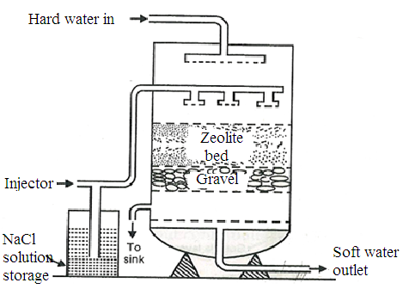
Zeolite Softener

Regeneration
After some time, zeolite is completely converted into calcium and magnesium zeolites and it ceases to soften water, i.e., it gets exhausted.
At this stage, supply of hard water is stopped and exhausted zeolite is reclaimed by treating bed with concentrated (10%) brine (NaCl) solution and used again for softening purpose.
CaZe + 2 NaCl Na₂Ze + CaCl₂

Advantages
- 10 ppm hardness is produced.
(ii) Equipment is compact and occupies small space.
(iii) There is no sludge formation.
(iv) Process requires less skill for maintenance as well as operation.

Disadvantages

(i) Treated water contains some quantity of sodium salts.
(ii) Replaces calcium and magnesium ions by sodium ions, but leaves all acidic.
(iii) Sodium carbonate hydrolyses to sodium hydroxide, which causes caustic embrittlement.
(iv) High turbidity water cannot be treated by this process.

6. Explain Ion-exchange or Demineralisation process. (May 13, 14, 15, Jan 14, 15, 16)
Ion-exchange or Demineralisation process
Ion-exchange resins are insoluble, cross linked, long chain organic polymers with porous structure. Resins containing acidic functional groups are capable of exchanging their H⁺ ions with other cations.
Those containing basic functional groups are capable of exchanging their anions with other anions.

Examples

- Cation exchange resins (RH⁺): Sulphonated styrene-divinyl benzene copolymers
- Anion exchange resins (R’OH–): Amino styrene-divinyl benzene copolymers, treated with dil. NaOH solution.

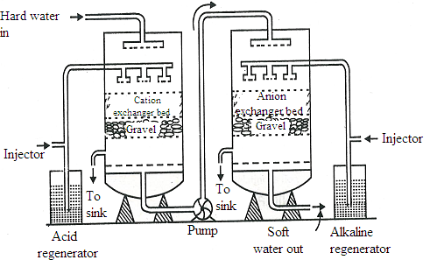
Ion-Exchange Softener

Process
Hard water is passed through cation exchange column, which removes all cations (Ca²⁺ and Mg²⁺) from
it, and equivalent amount of H⁺ ions are released.
2 RH⁺ + Ca²⁺ R₂Ca²⁺ + 2 H⁺
After cation exchange column, hard water is passed through anion exchange column, which removes all anions (SO₄²⁻ and Cl⁻) present in water and equivalent amount of OH⁻ ions are released.
ROH⁻ + Cl⁻ R’Cl⁻ + OH⁻
H⁺ and OH⁻ ions get combined to produce water molecule.

H⁺ + OH⁻ H₂O
Regeneration
When capacities of cation and anion exchangers to exchange H⁺ and OH⁻ ions respectively are lost, they are then said to be exhausted.
The exhausted cation exchange column is regenerated by passing a solution of dil. HCl or dil. H₂SO₄.
R₂Ca²⁺ + 2 H⁺ 2 RH⁺ + Ca²⁺
The exhausted anion exchange column is regenerated by passing a solution of dil. NaOH.
R’₂ SO₄²⁻ + 2 OH⁻ 2 R’OH⁻ + SO₄²⁻
The regenerated ion exchange resins are then used again.

Advantages
- This process can be used to soften highly acidic or alkaline waters.
- It produces water of very low hardness (2 ppm) suitable for high pressure boilers.

Disadvantages
- This equipment is costly and more expensive chemicals are needed.
- If water contains turbidity, then output of the process is reduced.
7. Explain Electro dialysis process. (Jan 11, 14, May 11, 12, 13, 16, 19)
Electro dialysis
In Electro dialysis process ions are pulled out of salt water by passing direct current, using electrodes and thin rigid plastic membrane pair.
Principle
When direct current is passed through saline water, sodium ions (Na⁺) start moving towards negative pole (cathode) while chloride ions (Cl⁻) start moving towards to positive pole (anode) through membrane. As a result, concentration of brine decreases in central compartment; while it increases in two side compartments.
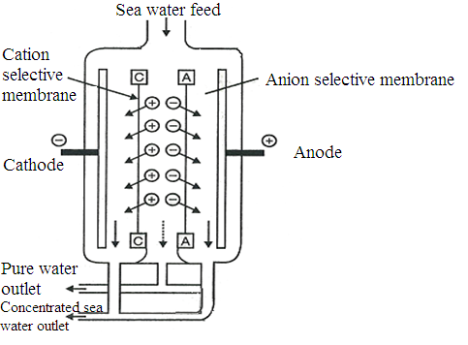
Electro dialysis cell

Ion selective membrane
For efficient separation, ion-selective membranes are employed. An ion-selective membrane has permeability for only one kind of ions with specific charge.
Example: Cation-selective membrane is permeable to cations only, because of charged fixed functional groups, reject anions.
Process
Electro dialysis cell consists of a large number of paired sets of rigid plastic membranes. Saline water is passed under a pressure of 6 kg/m² between membrane pairs and an electric field is applied perpendicular to the direction of water flow.
The fixed positive charges inside membrane repel positively charged ions, yet permit negatively charged ions to pass through. Similarly in the fixed negative charges inside other type of membrane repel negatively charged ions yet, permit positively charged ions to pass through.
Therefore, water in one compartment of the cell is deprived of its salts: while salt concentration in adjacent compartment is increased.
Advantages
- It is compact, cost of plant and its operation is economical.
- If electricity is easily available, it is best suited.

8. 50 ml of sample hard water required 35 ml of 0.01 M EDTA in the titration. 50 ml of same sample of water after boiling required 12 ml of 0.01 M EDTA. Calculate temporary, permanent and total hardness. (May 14, Jan 16)
50 ml of water sample = 35 ml of 0.01 M-EDTA
= (35 x 1000)/50 ml of 0.01 M-EDTA
= 700 ml of 0.01 M-EDTA
= 2 x 700 ml of 0.01 N-EDTA (Since, Molarity = 2 x Normality)
= 1400 ml (or 1.4 L ) of 0.01 eq CaCO₃
≡ 1.4 x 0.01 x 50 g CaCO₃ eq
Hence, total hardness = 0.7 g or 700mg of CaCO₃ eq
= 700 mg/L or 700 ppm
Now 50 ml of boiled water = 12 ml of 0.01 M-EDTA
1000 ml of boiled water = (12 x 1000) / 50 ml of 0.01 M-EDTA
= 240 ml of 0.01 M-EDTA
= 2 x 240 ml of 0.01 N-EDTA
= 480 ml (or 0.48 L ) of 0.01 eq CaCO₃
= 0.48 x 0.01 x 50 g CaCO₃ eq
Hence, permanent hardness = 0.24 g or 240 mg of CaCO₃ eq
= 240 mg/L or 240 ppm
Total hardness = Permanent hardness + Temporary hardness
Temporary hardness = (700-240) ppm = 460 ppm

